Week - 4 Microservices with Springboot 3

Exercise 1 - Creating Microservices for account and loan
Solution Code:
- AccountApplication.java:

package com.cognizant.account;

import org.springframework.boot.SpringApplication;
import org.springframework.boot.autoconfigure.SpringBootApplication;

@SpringBootApplication
public class AccountApplication {
public static void main(String[] args) {
SpringApplication.run(AccountApplication.class, args);
}
}

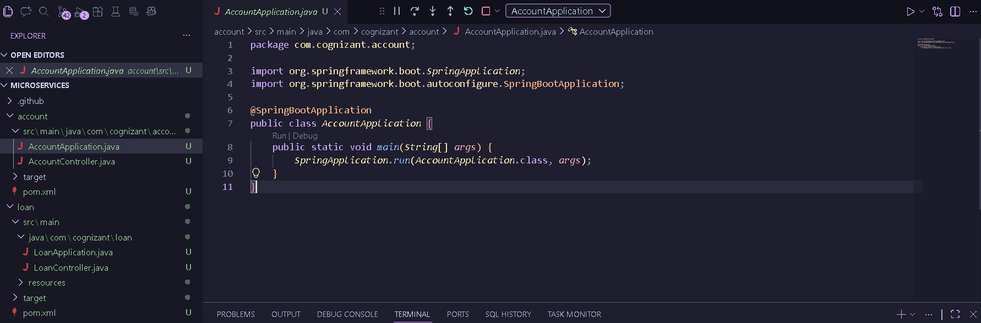

- AccountController.java:

package com.cognizant.account;

import org.springframework.web.bind.annotation.GetMapping;
import org.springframework.web.bind.annotation.PathVariable;
import org.springframework.web.bind.annotation.RestController;
import java.util.HashMap;
import java.util.Map;

@RestController
public class AccountController {

@GetMapping("/accounts/{number}")
public Map<String, Object> getAccountDetails(@PathVariable String number) {
Map<String, Object> response = new HashMap<>();
response.put("number", number);
response.put("type", "savings");
response.put("balance", 234343);
return response;
}
}
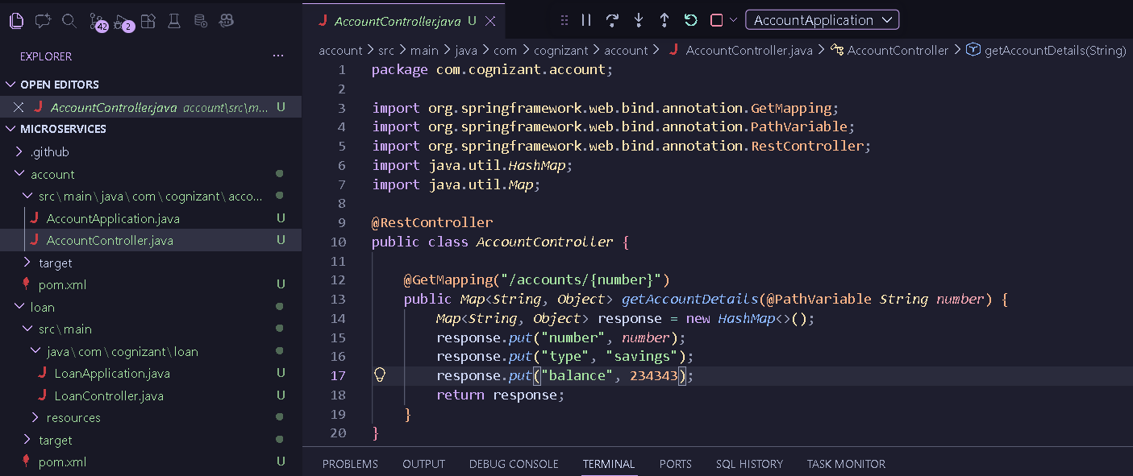
- LoanApplication.java:

package com.cognizant.loan;

import org.springframework.boot.SpringApplication;
import org.springframework.boot.autoconfigure.SpringBootApplication;

@SpringBootApplication
public class LoanApplication {
public static void main(String[] args) {
SpringApplication.run(LoanApplication.class, args);
}
}
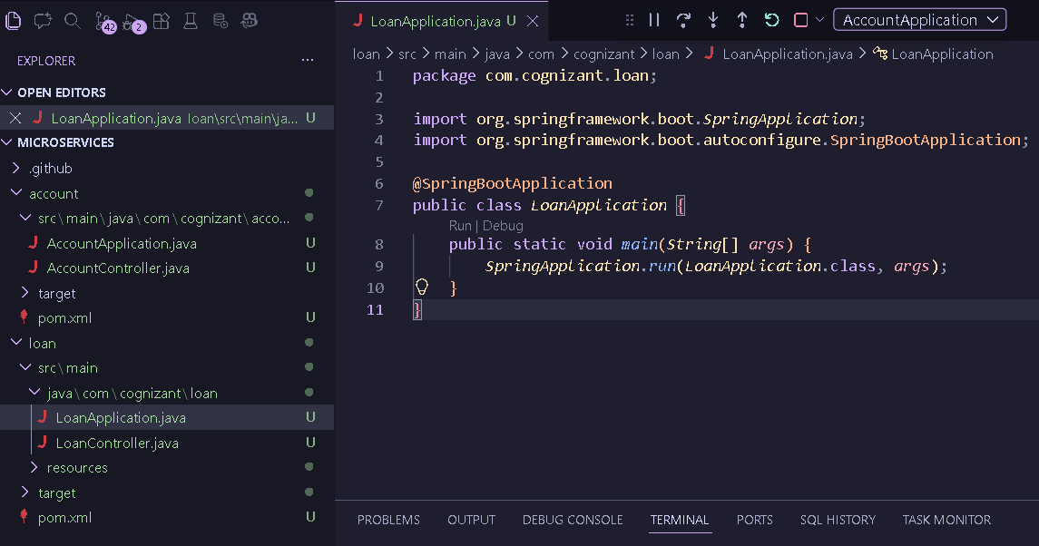

- LoanController.java:

package com.cognizant.loan;

import org.springframework.web.bind.annotation.GetMapping;
import org.springframework.web.bind.annotation.PathVariable;
import org.springframework.web.bind.annotation.RestController;
import java.util.HashMap;
import java.util.Map;

@RestController
public class LoanController {

@GetMapping("/loans/{number}")
public Map<String, Object> getLoanDetails(@PathVariable String number) {
Map<String, Object> response = new HashMap<>();
response.put("number", number);
response.put("type", "car");
response.put("loan", 400000);
response.put("emi", 3258);
response.put("tenure", 18);
return response;
}
}
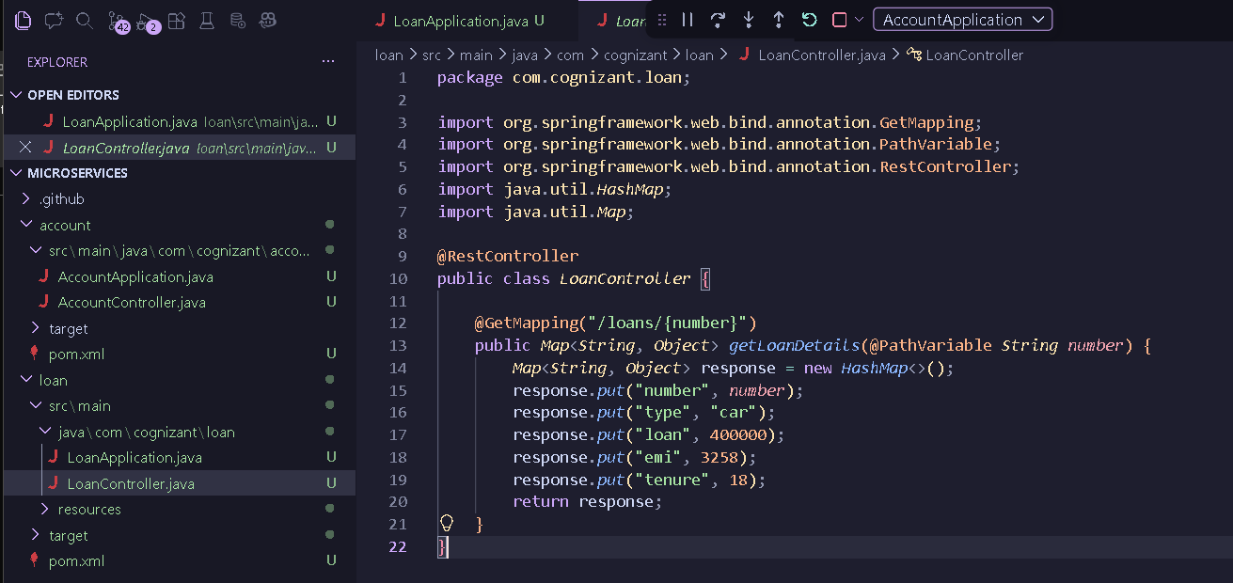

Output:
AccountApplication.java:
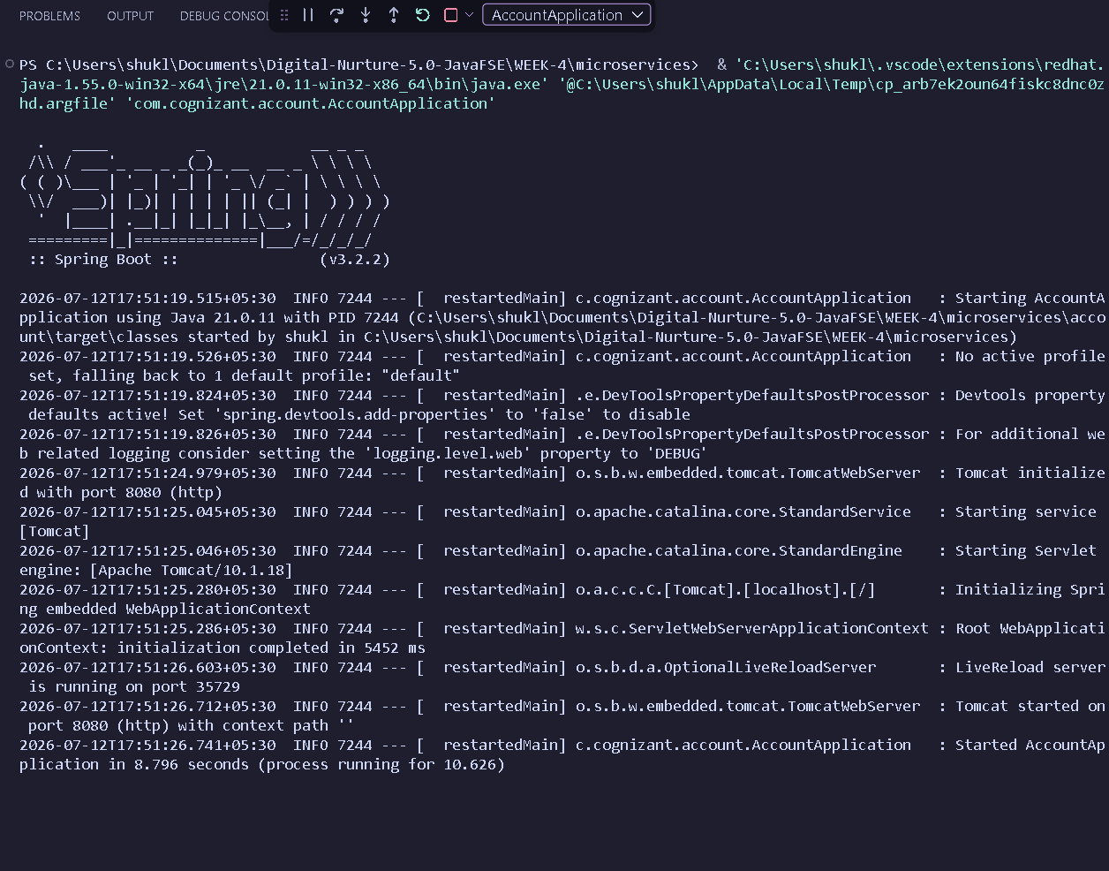

LoanApplication.java:
